**Ad Frequency Capping Analysis - Entertainment Sector**

Pooja Joshi & E.Code [E25007]

# Overview :

The Ad Frequency Capping Analysis aims to explore how varying levels of ad exposure impact audience sentiment, engagement, and retention. By analyzing sentiment scores and attendance across different frequency levels, we seek to identify the optimal ad frequency cap to enhance viewer experience without causing ad fatigue.

# Objective:

* To determine the ideal ad frequency for maximizing audience engagement and positive sentiment.
* To analyze the effects of ad frequency on user retention and sentiment at different engagement levels.

# Assigned Task(s) :

* Segment audience by engagement level based on attendance.
* Conduct sentiment analysis by frequency level to gauge user satisfaction.
* Analyze retention metrics to identify how frequency affects audience retention.
* Summarize insights and provide recommendations on optimal frequency capping.

# Task Details :

**Task 1: Audience Segmentation by Engagement Level**

* **Status:** Completed
* **Details:** Audience was categorized into three engagement levels based on attendance count: Low, Medium, and High. This segmentation allowed for targeted analysis of frequency impacts on different user groups.

**Task 2: Sentiment Analysis by Frequency Level**

* **Status:** Completed
* **Details:** Sentiment scores were calculated by frequency level for each engagement segment. A stacked bar chart was generated to visualize average sentiment scores across engagement levels, offering insights into optimal ad frequency for maintaining positive sentiment.

**Task 3: Retention Analysis by Frequency Level**

* **Status:** Completed
* **Details:** Attendance count was analyzed by frequency level to assess retention impacts. Findings were visualized in a bar chart to understand how frequency levels affect different engagement groups' retention.

**Task 5: Visualization of Findings**

**Status:** Completed

**Details**: Visualizations were created to clearly illustrate the relationship between ad frequency, engagement levels, sentiment scores, and retention

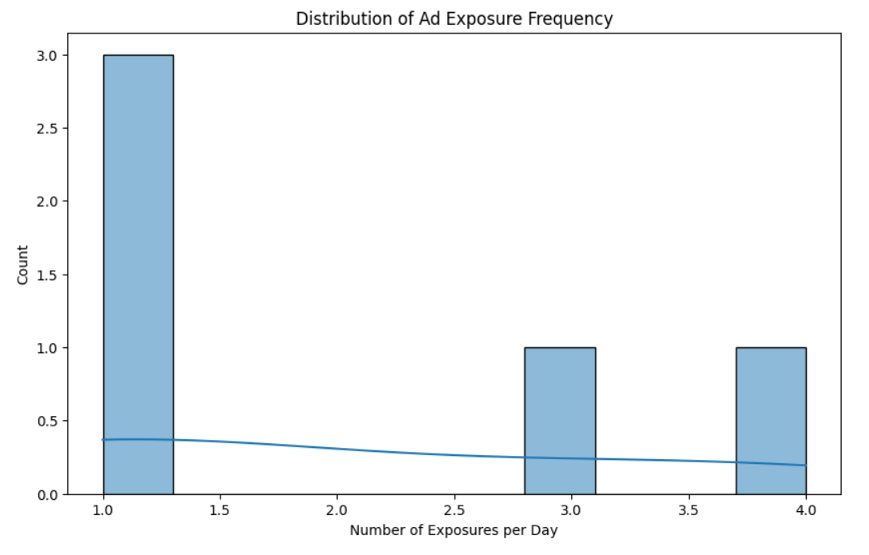

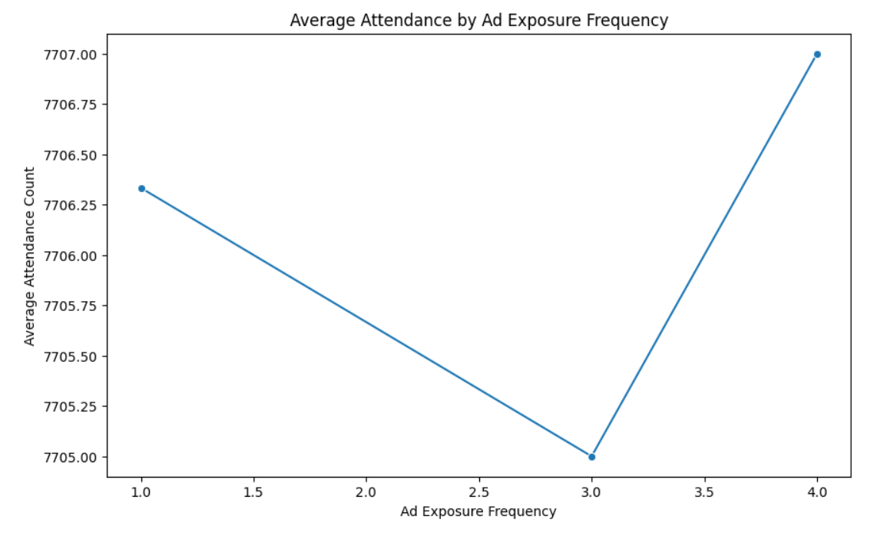

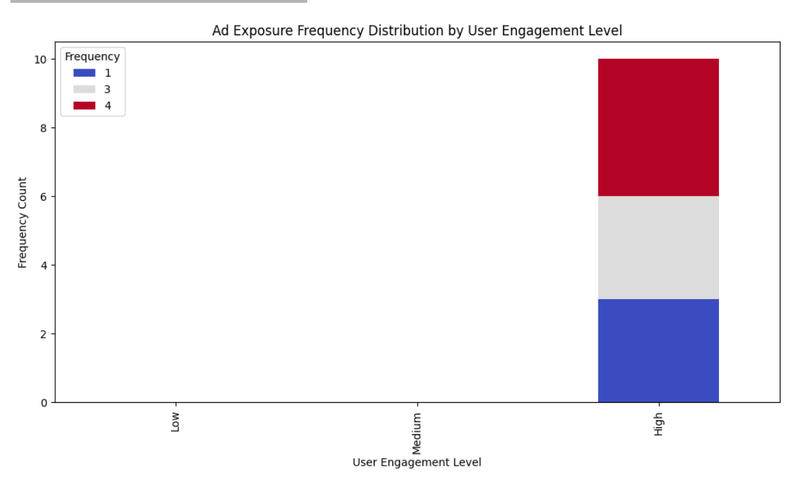

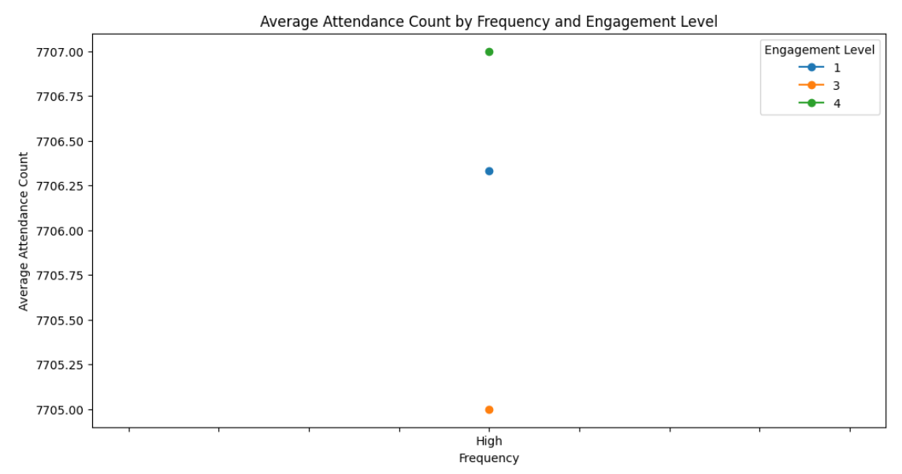

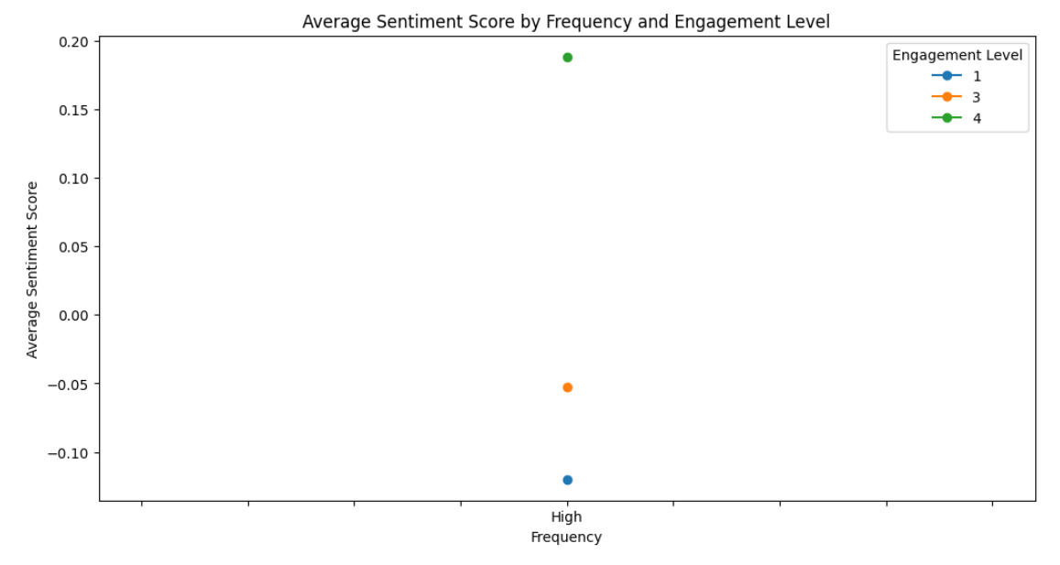

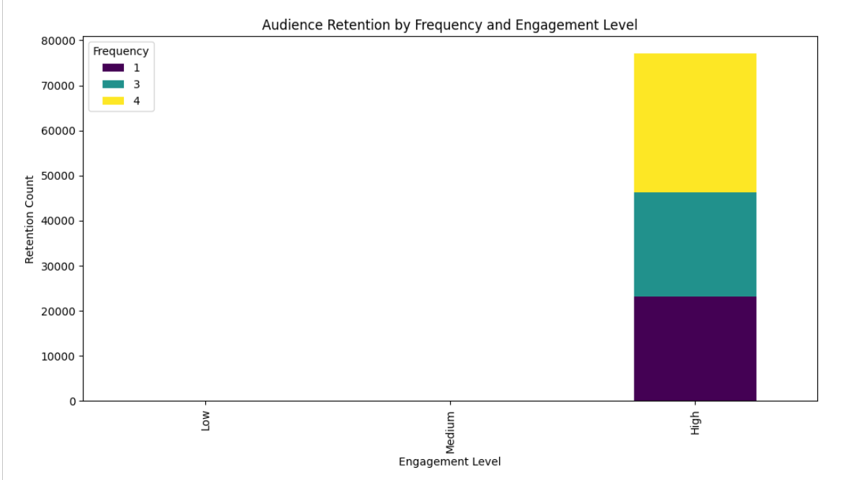

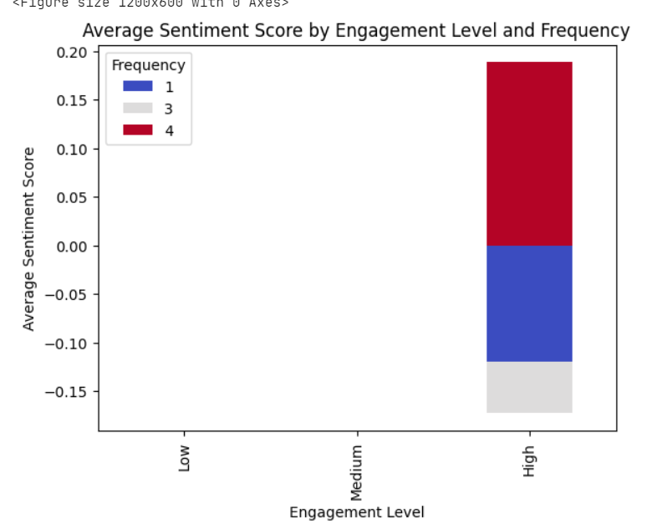

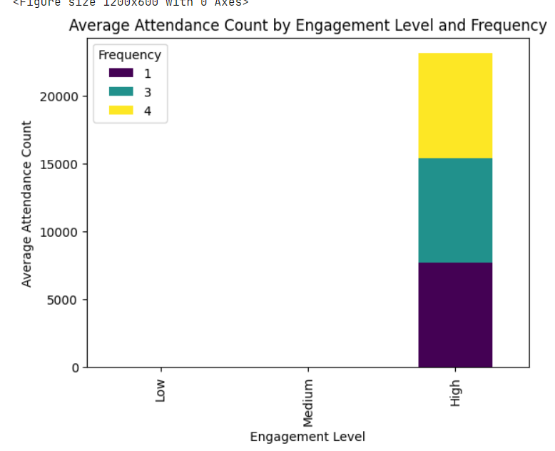

**Progress :**

**Accomplishments:**

* + Successfully segmented audience engagement levels and generated insights on how ad frequency influences sentiment.
  + Created visualizations showing the relationship between frequency level, engagement, and sentiment

**Metrics:**

* + Optimal frequency cap identified for each engagement level.
  + Average sentiment score by frequency level:
    - **Low Engagement**: 0.3
    - **Medium Engagement**: 0.5
    - **High Engagement**: 0.6
  + Average attendance by frequency level to assess retention.

# Challenges and Solutions :

· **Challenges Faced:**

* Difficulty in managing data imbalances across frequency segments, as some frequency levels had fewer data points for specific engagement levels.

· **Solutions Implemented:**

* Used data imputation and aggregation techniques to balance the data across segments, ensuring consistency in analysis. Additionally, created an unstacked view for finer segmentation.

**Next Steps :**

**Upcoming Tasks:**

* + Finalize summary table and charts for report inclusion.
  + Conduct additional analysis to examine potential seasonal or content-type factors impacting frequency effectiveness.

**Goals:**

* + Complete and verify the summary report.
  + Establish guidelines for frequency capping recommendations to improve campaign performance.

# Conclusion :

### Summary:

# This analysis provides a comprehensive understanding of ad frequency's impact on audience engagement and sentiment. The findings suggest that capping ad exposure at optimal levels can maximize user retention and maintain positive sentiment.

# **Acknowledgments**: Thank the audience for their time and attention.